Bipeen Sinha
MCT | AAI | CKA
Lab Manual

Create and Scale an Azure Virtual Machine

Table of Contents
1. Lab Objective 2
2. Lab Scenario 2
3. Lab Create Azure Virtual Machine 3
4. Check Basic Performance of VM Compute 7
5. Scale the VM Compute 8
6. Learning Objectives 11

Lab Objective

- Create an Azure Virtual Machine using the Azure Portal
- Understand VM configuration components (compute, storage, networking)
- Monitor VM performance (CPU, Disk, Network)
- Resize (scale) the VM to a higher configuration
- Validate the changes after scaling

Lab Scenario

You are working as a Cloud Engineer in an organization that is deploying applications in Microsoft Azure.

Initially, a Virtual Machine is created with a basic configuration to host a web application. After deployment, the application experiences increased load and requires better performance.

Your task is to:
- Create the VM with standard configuration
- Monitor its performance (CPU, Disk, Network usage)
- Scale the VM to a higher size to handle increased workload
This simulates a real-world scenario where applications need dynamic scaling based on demand.

Lab Create Azure Virtual Machine

- In The Azure Search , Type Virtual Machine and select it

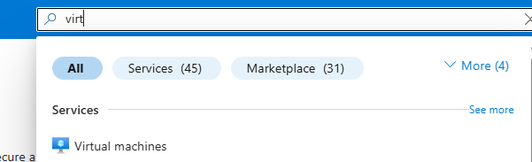

- In Computer Infrastructure Virtual Machine , Select Create Virtual Machine

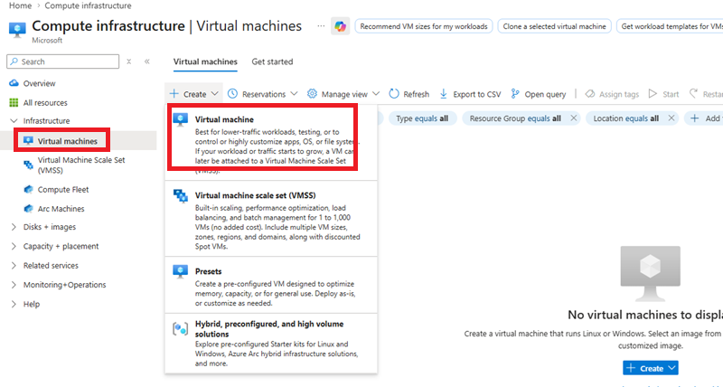

- In The Virtual Machine , Fill the Basic Details and Click Next

Subscription : ODL-AZ-XXXX
VMName : IN-VM-01
Region : WestUS2
Availability Option : No Infrastructure redundancy required
Security type : Standard
Image : Window Server 2025 Azure Edition
Size : IN-VM-01
Region : Standard_DS1_V2 – 1 CPU , 3.5 GiB Memory
UserName : Vmadmin
Password : Password@123

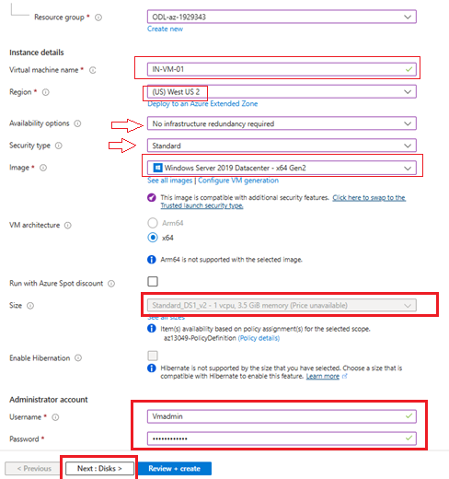

- In The Next Screen ( Disk ) Select Standard HDD and Click Next

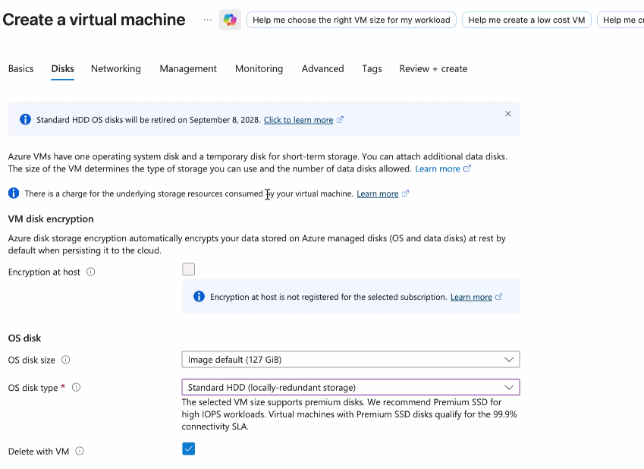

- Click Review + Create Create

- Once Machine Get Created, Click Go To Resource Button and you should be in VM Console

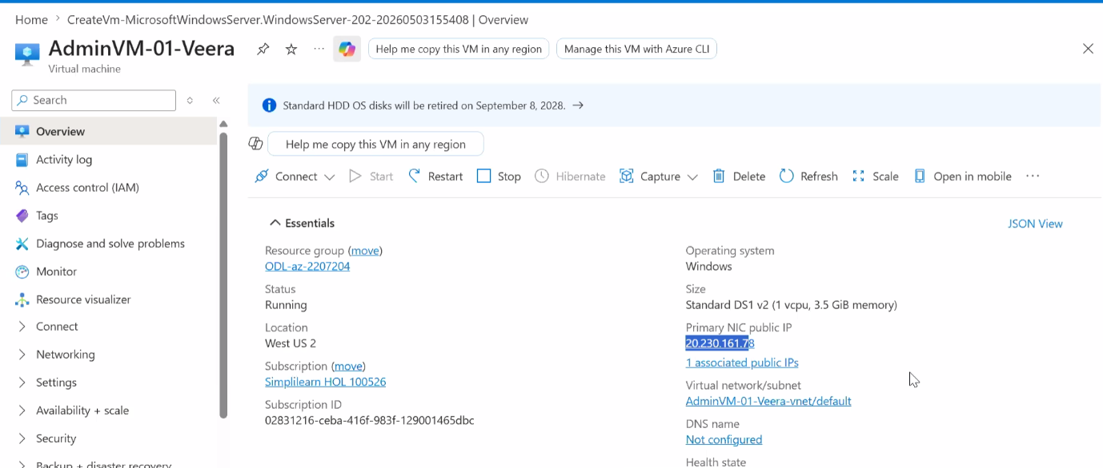

Check Basic Performance of VM Compute

- In the VM Console click Overview and Click Monitoring Tab
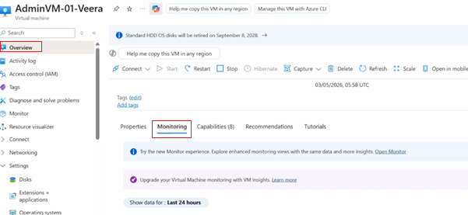

- In Monitoring Scroll below to see Performance and utilization

  - CPU Utilization
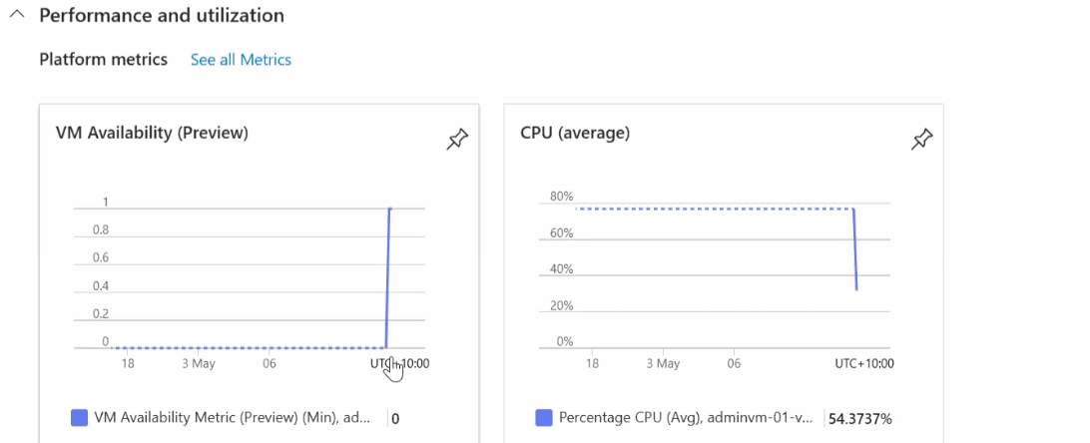

  - Disk Utilization

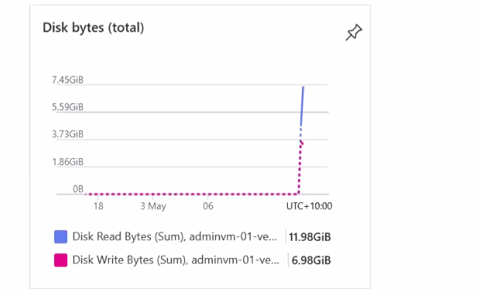

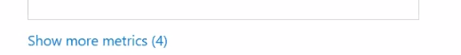
  - Network Utilization

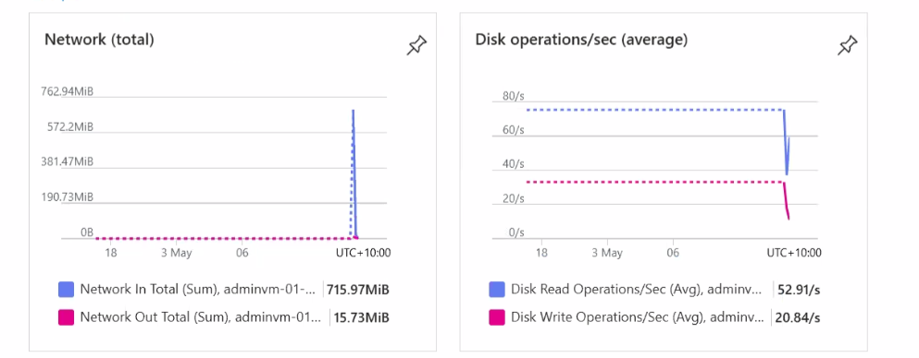

Scale the VM Compute

- In the overview , check the current VM Size

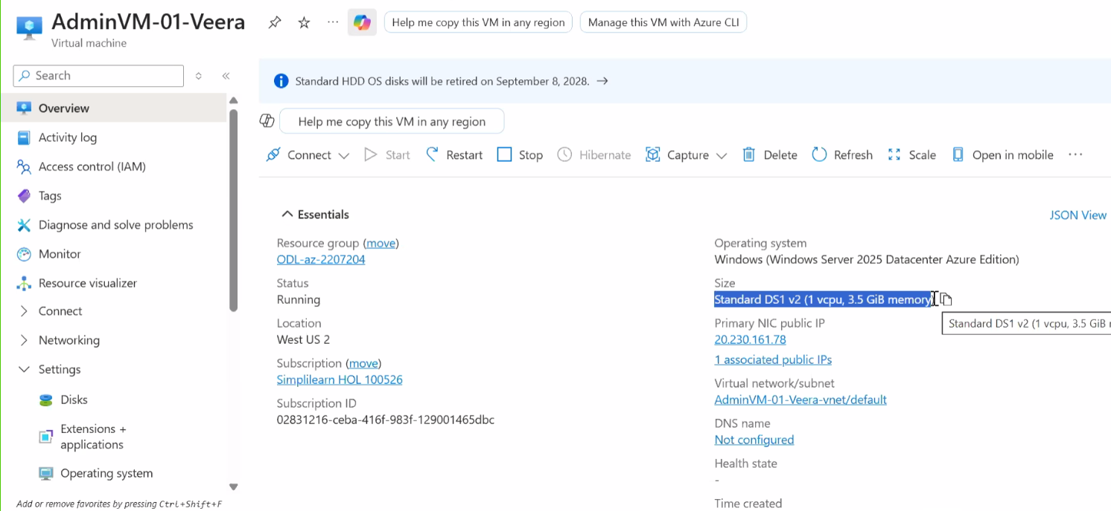
- From left side menu expand Availability + Scale and Click Size , Select higher size ( DS2_V2)

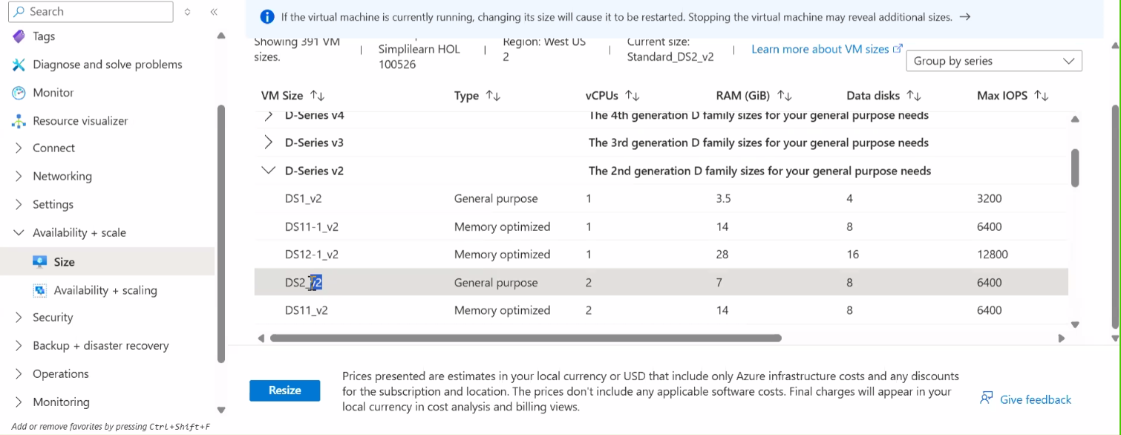
- Click Resize to confirm Resize of VM

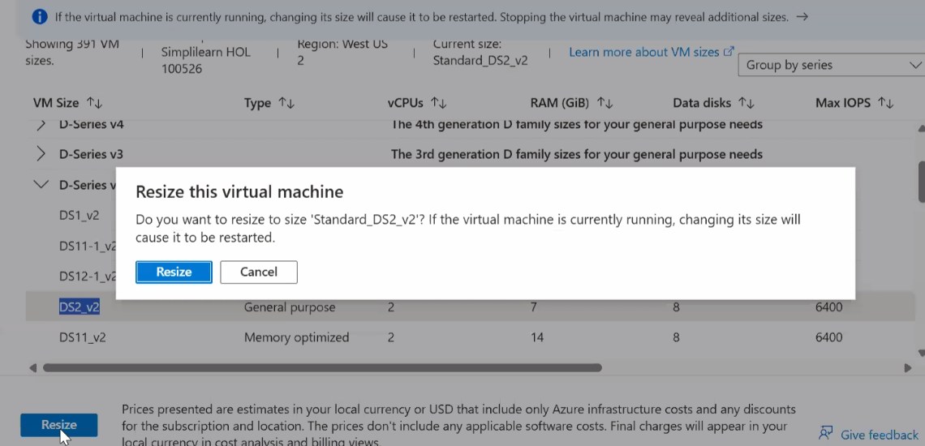

- Wait for Success Manage

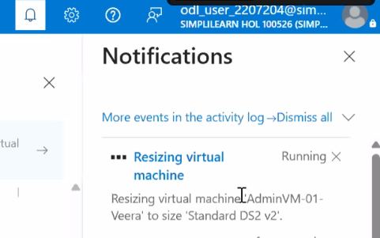

- Go Back to Overview and confirm you should see the new Size

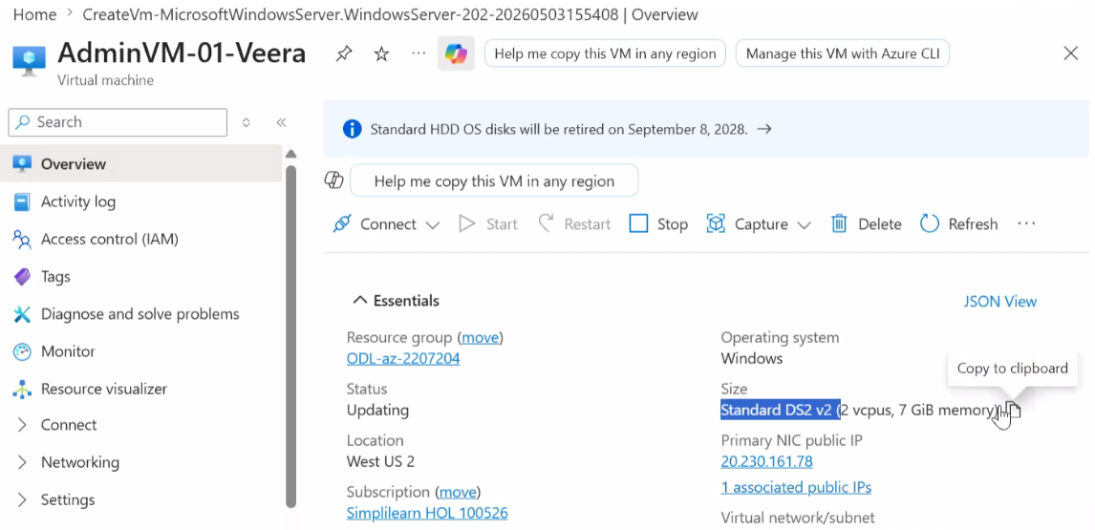

Learning Objectives
By the end of this lab, learners will be able to:
- Understand Azure Virtual Machine deployment process
- Identify key VM components (image, size, disk, networking)
- Monitor VM performance metrics in Azure Portal
- Analyze when scaling is required
- Resize (scale up) a VM to improve performance
- Validate and confirm VM size changes after scaling

